SMart is a one-day celebration at Finsbury Park Picturehouse on July 11th of the creative impact of Smartphone Filmmaking - from no-budget DIY shorts to internationally acclaimed feature films

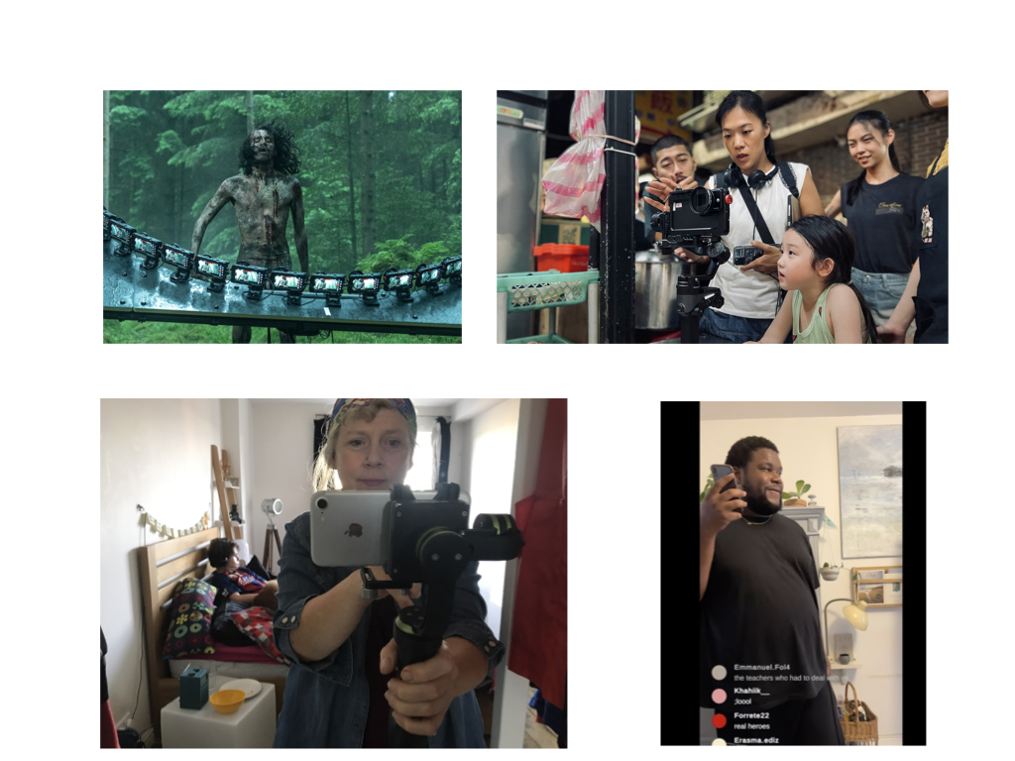

Smartphone filmmaking has become one of the most dynamic, exciting and accessible areas of contemporary screen culture, lowering barriers to entry while creating new visual languages for cinema. The day includes screenings, filmmaker conversations and industry panels featuring award-winning feature documentary Motherboard, filmed over 20 years on five generations of smartphones, and Shih-Ching Tsou’s acclaimed feature Left-Handed Girl (edited by Sean Baker). Other examples include Bradley Banton’s Instagram Live-inspired drama More Life

Left-Handed Girl will be followed by a videoed Q&A with director Shih-Ching Tsou. Following the screening of smartphone documentary Motherboard, BAFTA-winning filmmaker Victoria Mapplebeck and subject of the film Jim Mapplebeck, with do a live Q and A hosted by writer and broadcaster Janet Ellis.

The programme also features a smartphone filmmaker panel with clips, chaired by Adam Gee, with Bradley Banton, Tuwaine Barrett, Victoria Mapplebeck, Trim Lamba, Aamana Khan and Anna Novikova. This one-day event is a celebration of how mobile technology is reshaping contemporary cinema and audio-visual culture, and opening up new ways to shoot, tell stories and reach audiences.

LEFT-HANDED GIRL

Directed by Shih-Ching Tsou
Taiwan, France, 2025

Picturehouse Finsbury Park – 11.00
When Shu-Fen and her two daughters move to Taipei to start a new life running a noodle stall in the city's bustling night markets, old tensions and family secrets begin to surface. As the family navigates the pressures of work, adolescence and independence, each must find their own path forward.
Set amid the colour and chaos of Taipei’s night markets, the film combines authentic performances with a vivid sense of place to create a deeply human story about family, identity and belonging
Co-written with Sean Baker, Shih-Ching Tsou's acclaimed debut feature was shot on an iPhone with a small, agile crew, capturing the energy, intimacy and unpredictability of everyday life in Taipei's crowded streets and night market.
The screening will be followed by a recorded Q&A hosted by Victoria Mapplebeck, in which Tsou discusses her approach to smartphone filmmaking, working with a lightweight crew, and shooting in real-world locations.
Motherboard
Filmed and Directed by Victoria Mapplebeck
UK 2025

Picturehouse Finsbury Park – 14.00

Motherboard is a smartphone feature exploring motherhood, filmed on 5 generations of smartphone over 20 years by BAFTA award-winning director Victoria Mapplebeck.

At 38, Victoria found herself single, pregnant, and broke. Unable to combine motherhood with freelance directing, she was forced to abandon her career in TV, instead turning the camera on herself and her son, Jim. Victoria recorded hundreds of hours of footage, capturing each twist and turn in Jim’s life, from the thumbs-up Jim gave her during her first pregnancy scan to his first day at college

MOTHERBOARD charts the real-life comedy and the roller coaster of solo parenting. Victoria captures a life where both she and Jim survive her breast cancer diagnosis, two generations of absent fathers and Jim’s rollercoaster teen years.

Honest, funny and infinitely relatable, MOTHERBOARD is the antidote to the unrealistic expectations we have about motherhood and a film for anyone who wants to see family life in all its unfiltered glory

Motherboard will be followed by a Q and A with Victoria Mapplebeck and Jim Mapplebeck hosted by Writer and Broadcaster Janet Ellis

Smartphone Filmmakers Panel

Smartphone Filmmaker panel chaired by Adam Gee Smartphone filmmaking has become one of the most dynamic, exciting and accessible areas of contemporary screen culture, lowering barriers to entry while creating new visual languages for cinema. This panel celebrates the best of such filmmaking and spotlights some of the filmmakers pushing this movement forward, from no-budget DIY shorts to critically acclaimed features. Confirmed directors (who will illustrate their work with clips) include: Victoria Mapplebeck - Motherboard Bradley Banton - More Life, plus its star Tuwaine Barrett Trim Lamba - Cracked Screen Aamana Khan - Homebound Anna Novikova - Deeper Underground

Picturehouse Finsbury Park – 16.15

Press quotes;

“SMart celebrates the extraordinary creative freedom that smartphone filmmaking offers. It lowers barriers, opens up cinema to new voices, and allows filmmakers to work with an intimacy and immediacy that traditional production often can’t match. For me, making Motherboard over 20 years on five generations of smartphones showed how powerful this technology can be — not just as a camera, but as a way of telling deeply personal stories.”

– Victoria Mapplebeck

“Why I’m so fired up by smartphone filmmaking, beyond the dynamism and inventiveness, are the things it enables you to shoot which would be way harder or even impossible any other way.”- Adam Gee “ – Adam Gee
Festival Team
SMart is co-curated by BAFTA-winning filmmaker Victoria Mapplebeck and former Channel 4 commissioner and digital innovation leader Adam Gee, in response to the rapid global growth of smartphone filmmaking as a fresh, creative and accessible form of cinema. This one-day celebration follows up the inaugural SMart film festival and is intended as an annual event.
Both founders bring extensive experience across production, innovation and festival programming. Victoria Mapplebeck is internationally recognised as a pioneer of smartphone filmmaking, having worked exclusively with mobile technologies for over a decade. Her BAFTA-winning short Missed Call and her feature documentary Motherboard, were filmed entirely on smartphones, the latter released theatrically in 2025 to critical and awards acclaim, and demonstrate artistic excellence and industry impact. Victoria is Professor of Digital Arts at Royal Holloway, University of London.
BAFTA-winning digital creator, Adam Gee, brings senior commissioning and innovation experience from Channel 4, Little Dot Studios and CAA, alongside curatorial work across digital storytelling and emerging media. He is currently Head of Documentary Campus Masterschool in Berlin.
This event builds on the success of the 2021 online edition of SMart: The London International Smartphone Film Festival which attracted outstanding international submissions and strong media attention.

