
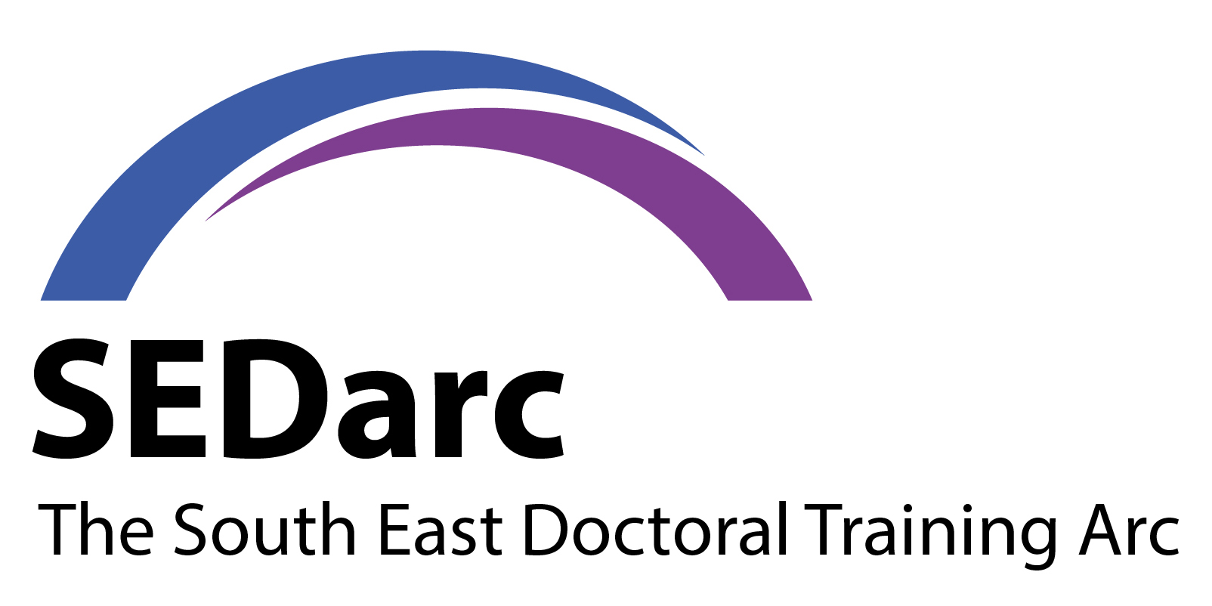
SEDarc DTP POST-DOCTORAL FELLOWSHIPS COMPETITION
EXPRESSION OF INTEREST APPLICATION FORM 2025

The deadline to submit your expression of interest to SEDarc@rhul.ac.uk is 23:59 GMT on 16 April 2026. To be eligible you must:
- Have been awarded a PhD or have passed your viva voce with minor amendments by the application deadline of 1 June 2026 and have been awarded your PhD by the fellowship start date of 1 October 2026.
- Have no more than 15 months of active postdoctoral experience. This is measured from the applicant’s viva voce pass date to the application deadline of 1 June 2026.
- Permanent members of staff in an academic position with a research component are not eligible for this scheme.
Personal Information
Full name | Click or tap here to enter text.
SEDarc university you are applying to | Choose an item.
SEDarc theme | Choose an item.
Expected or actual PhD thesis submission date | Click or tap to enter a date.
Expected or actual date of the viva voce examination | Click or tap to enter a date.
PhD title
Click or tap here to enter text.
PhD abstract
Click or tap here to enter text.
PhD lay summary
Click or tap here to enter text.
Full name of PhD primary supervisor
Click or tap here to enter text.

Post-Doctoral Fellowship Research Project
Project title (up to 150 characters including spaces)
Click or tap here to enter text.
Provide a plain-language summary of your proposed research, suitable for a general audience. This summary should outline the main aims of the fellowship in an accessible, engaging way that can be understood by readers without specialist knowledge (max. 550 words).
Click or tap here to enter text.
List the main objectives of the fellowship (max. 250 words)

Please specify concisely the aims and objectives that should be achieved by the end of the fellowship. These could include some, but not all, of the activities suggested below. Alternative activities may also be proposed but it is important that the programme of work is realistic and feasible within the proposed duration of the fellowship.

- Produce publications in order to help establish track record
- Engage with a range of different audiences to communicate research findings
- Build networks to develop impact opportunities and inform and support further development
- Collaborate with users through an internship or placement to help develop professional and transferrable skills and understanding of users’ organisations
- Further training to improve research and related skills
- Developing funding proposals
- Teaching, if this is aligned with the wider purposes of the fellowship (up to a maximum of six hours per week)
- Internships or placements, providing they are an integral part of the fellowship
- Research visits to internationally leading research organisations – either in the UK or abroad – for the purposes of research collaboration, training, and/or access to data or other resources not available at the applicant’s host organisation.
Click or tap here to enter text.
What impact would you have through undertaking this fellowship, both within and beyond your field of research This could involve an influence on policy and practice, as well as an impact on academia (max. 200 words)
Click or tap here to enter text.
What difference would the fellowship make in helping you to achieve your career aspirations? (max. 200 words)
Click or tap here to enter text.
Timeline for the proposed programme of activities (e.g. Gantt chart).
Click or tap here to enter text.

Mentor details
Name of your proposed mentor | Click or tap here to enter text.
Email address | Click or tap here to enter text.

Summary of resources required for project
Fellowship proposals will be costed on the basis of full Economic Costs (fEC). If a fellowship is awarded, ESRC will provide funding at 80% of the fEC costs requested. The research organisation must agree to find the balance of fEC for the proposal from other resources. All proposals will be subject to ESRC’s funding rules as outlined in the Research Funding Guide (https://esrc.ukri.org/files/funding/guidance-for-applicants/research-funding-guide/).

The total cost of each fellowship includes the following:
- Directly incurred: Fellow’s salary costs; Travel and subsistence*; Other costs *
- Directly allocated: Estate costs
- Indirect costs

It is not necessary to address all the above areas of costs in your initial application to SEDarc, but it would be helpful if you could address the two section that are marked * in the above list.

* These headings are limited to a maximum of £7,500 and such include such costs such as mentoring, travel and subsistence, conference attendance, training, and fieldwork, etc. There is a maximum limit of mentor(s) costs of up to £1,500. Where an RO costs infrastructure technicians separately to estate costs, these will not be counted within the £7,500 limit on other costs.
Summary fund heading | Fund heading | Full economic cost
Directly incurred | Staff (fellow salary only) | 0.00
Directly incurred | Travel and subsistence* | 0.00
Directly incurred | Other costs* | 0.00
Directly incurred | Sub-total | 0.00
Directly allocated | Estates costs | 0.00
Directly allocated | Other Costs | 0.00
Directly allocated | Sub-total | 0.00
Indirect costs | Indirect costs | 0.00
Total |  | 0.00

Applicant Financial Resources Narrative
Explain why the resources indicated in the table are needed, taking account of the nature and complexity of the programme of work proposed. It is not sufficient merely to list what is required.
Click or tap here to enter text.

Next steps
Please upload your completed form using the link PDF EOI 2026 and attach your CV (maximum two sides of A4), which should include a list of any relevant publications, details of awards and prizes, impacts, and relevant research and work experience. You will also be asked a series of questions for equal opportunities monitoring, please note that responses to these questions will be anonymised and held securely.
Name | Click or tap here to enter text.
Date | Click or tap to enter a date.

