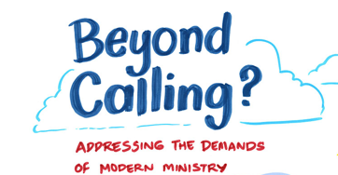

Workshop Report
Oxford, 24th October, 2024




Summary
- Beyond Calling? Addressing the Demands of Ministry workshop took place on 24th October 2024 in St Barnabas Church, Oxford, bringing together social science researchers and clergy to discuss relevant research and experiences around the demands of ministry.

- The event was organised and reported by Prof Gillian Symon (Royal Holloway University of London), Dr Rebecca Whiting (Birkbeck University of London) and Dr Rebecca Taylor (University of Southampton) and sponsored by the ESRC Festival of Social Science.

- The morning session focused on experienced demands. Talks from Dr Liz Graveling (Living Ministry Project) and Prof Gillian Symon (Pandemic Ministry Project) introduced various challenges and tensions experienced by clergy as they pursue their vocation, including the demands of formal and felt accountability (Graveling) and emphasising the importance of achieving a meaningful yet sustainable pattern of ministry (Symon).

- Prompted by these presentations, each group discussed their own experience:
  - A sense of vocation and meaningful ministry is a privilege but can also create unrealistic demands. Demands appear to be potentially unlimited, ironically leading to cutting down on activities that contribute to a sense of vocation. Support is urgently needed if demands mean clergy struggle to articulate their vocation.
  - Invisible demands included existential and psychological demands such as ‘masking’ one’s own feelings and hiding concerns about the wider Church from the parish. Incumbents also identified various invisible tasks and unspoken expectations of their role from both parish and Church. Invisible tasks and expectations may explain some of the difficulties curates experience moving into incumbency.
  - Digital solutions stemming from the pandemic can help manage demands but can also increase expectations of availability.

- The afternoon session focused on support strategies. Gill Lovell (CMDA, Oxford Diocese) outlined the intentional conversations that enable a ‘thinking space’ for clergy and the Oxford Diocese system of ministry accompaniers. Prof Neil Conway (Royal Holloway University of London) summarised research that has quantified the amount of time clergy spend on administration and led to the introduction of admin assistants to help manage this commitment.

- Prompted by these presentations, each group discussed their own experience:
  - Coaching interventions are welcomed. Clergy also valued, for example, retreats, national support networks, training events, and the CMD grant. However, there were also concerns that interventions for individual clergy ignore more structural issues.
  - Personal strategies for managing demands included: supportive social networks; overt appreciation; efficient internal systems; and regularly blocking time out, including for valued hobbies.
  - There was ambivalence about administrative activities. While some saw admin as a distraction from more meaningful activities, others saw it as a welcome break from these.

- Clergy also expressed some general reservations and limitations in relation to interventions to manage demands:
  - It was suggested that the increase in demands was emanating from structural and cultural changes in the Church and could not be resolved without also considering interventions at this level.
  - Concerns were raised that interventions are removed from the everyday experience of ministry. More “grassroots” consultation and interventions driven by clergy would be valuable and empowering may be more effective than top-down driven interventions.
  - Having a sense of vocation may be a ‘hostage to fortune’, leading to feelings of “never being enough”. It is important to ask for help and not try to be a “superstar” driven by vocation.
  - Role modelling by senior clergy would help in “giving permission” for self-care.
  - There was an apprehension that those who most needed help were those least able or likely to ask for it so systems need to be in place to identify struggling clergy.

- Looking across the concerns expressed, ideas for future actions are summarised in five areas: Training; Everyday Ministry Practice; Supporting Clergy with Overwhelming Demands; Bottom-Up Group Level Interventions; and Changes at National Church Level. These ideas are necessarily broad at this stage and need further discussion and detail.

- Participants were very positive about the event and as a consequence intended to take a variety of actions, including engaging with some of the suggested interventions and contacting local clergy to offer support.

- The organisers have provided a template for this workshop intervention for use elsewhere and this is outlined in the Appendix.


Introduction
This workshop was organised by Prof Gillian Symon (Royal Holloway University of London), Dr Rebecca Whiting (Birkbeck, University of London) and Dr Rebecca Taylor (Southampton University). They are the authors of the report “The Reformation of the 21st Century?” Church of England Clergy Experiences of Ministry during the Covid-19 Pandemic.
The event took place on 24th October, 2024, and was hosted by St Barnabas Church in Jericho, Oxford, with the permission and support of Fr Christopher Woods. The event was graphically recorded by Laura Sorvala whose images illustrate this report.
The event was funded through the Economic and Social Research Council (ESRC) Festival of Social Science. The festival is an annual free celebration of the social sciences which is delivered every Autumn by UK universities. One of the aims of the Festival is to promote and increase awareness of the contribution social science makes to the wellbeing of UK society and economy.
The event focused on the demands of ministry and how these might be addressed. From the research literature, we interpret ‘demands’ as the efforts that clergy expend to fulfil expectations of their role as well as the psychological demands emanating from the nature of that role. Such demands can overwhelm the resources available to clergy including time, energy and external support. Demands can conflict with each other creating tensions which are difficult to resolve. Overwhelming demands challenge wellbeing and can lead to burnout.
The goals of the event were to:
- bring clergy together to share experiences, using insights from social science research and practice examples to trigger discussion.
- generate ideas for strategies to manage demands which can be implemented directly by individuals and also inform current strategies and debates in the Church.
- demonstrate a workshop process that can be adapted in more local contexts to enable clergy to discuss their own experiences, working together at a grassroots level to find both social and structural solutions to the demands of modern ministry.
This report is an overview of the day. Summaries of the presentations are provided followed by highlights from the ensuing discussions. Participant names are not included in the report. The aims of this report are to:
- Share clergy experiences and insights more widely to provoke discussion and ideas for change.
- Evaluate current strategies for supporting wellbeing in the Church.
- Share the template for future similar initiatives (see Appendix).

If you would like to discuss any aspect of this report, including running your own event, please contact Gillian Symon (gillian.symon@rhul.ac.uk) or Rebecca Whiting (r.whiting@bbk.ac.uk).
EXPERIENCED DEMANDS
The morning session focused on identifying and explaining the requirements and pressures of modern ministry. Two research projects that have explored the kind of demands felt by clergy were presented.
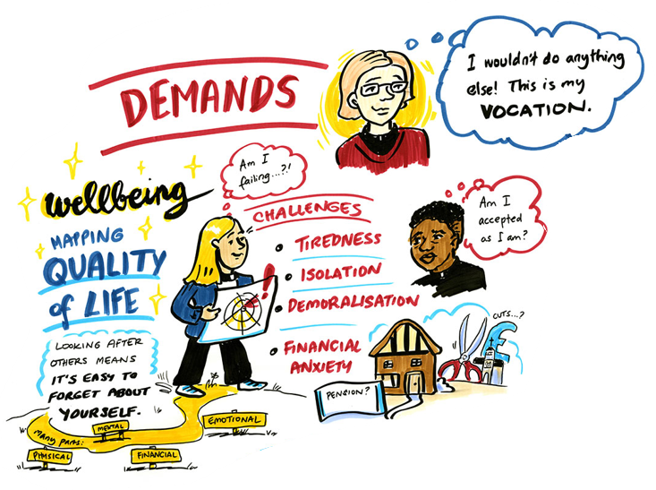

Dr Liz Graveling from the Living Ministry project, Church of England, presented a summary of recent results from her ongoing survey of clergy wellbeing. The project has been mapping wellbeing across five areas of clergy life since 2017: Spiritual and Vocational; Financial and Material; Physical and Mental; Relationships; and Participation.
- Four key wellbeing challenges for clergy have been identified over time: tiredness, isolation, demoralisation and financial anxiety.
- While wellbeing during the pandemic decreased for all categories of clergy surveyed, the latest 2023 survey suggests this has rebounded for most except Incumbents whose wellbeing across these challenges continues to decrease.
- One reason for these continuing difficulties is that formal accountability structures in the Church (e.g. statistics for mission) squeeze out clergy’s sense of vocation, which is the main motivation for ministry.

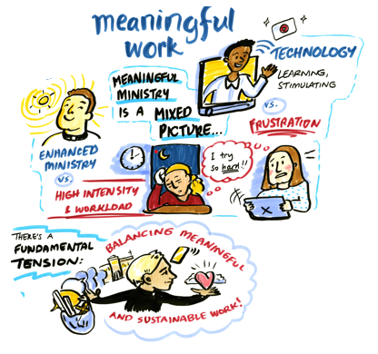
Professor Gillian Symon on behalf of the research team from the Pandemic Ministry project, provided examples of particular well-being challenges experienced during the pandemic and, drawing on the concept of meaningful work, how these related to various ongoing tensions of ‘meaningfulness’ for clergy.
- During the pandemic enhanced ministry was encountered, including the acquiring of valued new digital skills. However, exceptional effort in trying to produce meaningful online content for parishioners also led to exhaustion and frustration.
- Acknowledging individual limits and working as a group (e.g. as a benefice) to provide solutions was helpful in coping with increased demands during the pandemic.
- The pandemic exacerbated existing tensions such as: equality of access vs value of physically meeting in church; exploiting digital skills vs additional demands created; sharing resources vs providing a unique local offering; and enabling flexibility for congregations vs community building. Experienced demand comes from constantly trying to negotiate these tensions of meaningful ministry.
- The main underlying tension to be addressed was how to achieve a meaningful yet sustainable pattern of ministry including addressing how meaningful ministry can be sustained and nurtured in a digital and resource-strapped world.

Group Discussions of Experienced Demands
The five discussion groups were asked to consider three questions around experienced demands (see Appendix). Major themes from these discussions are summarised under three headings below.

Reflecting on the research and own experience
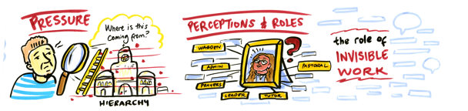
In general, participants agreed with the wellbeing challenges identified by the speakers, although it was recognised there might be individual differences depending on personal context. Self-awareness was fundamental in recognising these challenges and when support was required. It was also suggested “that stress is inevitable and creative and that love is revealed in coping with difficulties”.
- In relation to demands, participants felt these could be unlimited, with clergy having to be “omni-competent” and pastoral care, in particular, potentially having no boundaries. Endless emails, a constant inflow of new projects (as opposed to consolidation of existing work), a decline in volunteers and lack of new ordinations fed into these increasing demands. Together with constant “gear shifting” between extreme highs and lows, these demands contributed to both a lack of time and general feeling of tiredness.
- Consequently, clergy had to adopt “blinkers” (ignore some demands) or give up on some (valued) tasks (e.g. keeping up with contemporary theological thinking). Unfortunately, tasks that are relinquished may be those very tasks that are crucial to a sense of fulfilling vocation (e.g. pastoral care) because these tasks can be done by others.
- There was much discussion of the issue of accountability. Participants felt the weight of responsibility to fulfil Church demands but that such fulfilment was not under their own control. Given the increased demands, some objectives were ignored but then this had consequences for perceived performance. While Bishops could be sympathetic, discussion was too often couched in terms of performance rather than vocation. Beyond the Church, a felt responsibility as community leader and peace-maker was reported.
- Clergy also related to the concepts of vocation and meaningful ministry. A feeling of vocation was positioned as a both a “pain and a privilege; crucial to keeping going” but potentially contributing to unrealistic demands. It was suggested that a sense of vocation could be undermined by over-managerialism: “being, loving, prayer crowded out by achievement”. At the same time, does “morality have answers to the nuts and bolts of everyday ministry?” Overall, the Church’s general model of operation could be more ‘relationship’- than ‘institutional’- based. In keeping with the reported lower wellbeing of incumbents, it was felt that associates and curates probably experienced more meaningful ministry because they had less accountability. Support was urgently needed if demands were leading to clergy struggling to articulate their vocation.

Invisible demands
When asked about the invisible or unacknowledged demands place on them, participants’ responses fell into three main areas, however, we should note that one participant also noted that “no-one sees everything I do so everything is invisible to someone”.
- Some invisible demands were existential or psychological in nature. Age, gender and class were reported as adversely shaping experience but under-acknowledged: “much easier to be an Oxbridge male”. Participants also reported not being able to “be oneself” and engaging in “masking” and “self-censoring” which creates a constant psychological burden. There was a problem of living with the cognitive dissonance of wanting to be compassionate (related to vocation) but, in reality, having to navigate tensions. This was compounded by having to absorb problems as confidentiality limits any sharing of these problems. Increased demands could lead to “self-soothing” behaviours (e.g. drinking) which are under-acknowledged. Wider existential problems in the Church (e.g. finances, proposed changes, tensions between Church traditions and etc) cause clergy anxiety but are invisible to congregations and the parish.
- As above, some tasks will always be invisible to at least someone, but clergy highlighted in particular: the extra effort needed to be collaborative and also lead; organising events; navigating relational boundaries; working longer than contracted hours; and the demands from family which have to be managed alongside parishioner requirements. These latter can include helping parishioners with their own work outside the Church (e.g. Ofsted inspections). It was suggested that the demands of everyday ministry may be invisible to the Church hierarchy, with the leadership “not recognising it is a different world”. The invisible nature of these tasks, the shielding of curates from accountability (see above) combined with a lack of suitable training at vocational college, contributed to the difficulties curates experience moving to incumbency. Having a curate and explaining work to them, acted as a “mirror” that made incumbents’ invisible work more visible to themselves. Overall, it was not clear to clergy what “counted” as a working day.
- Clergy recognised a number of invisible expectations and assumptions coming from others. The easy accessibility that comes from living in the parish can lead to an expectation that clergy will always be in the church and will immediately respond to issues raised (particularly over email). There is also an assumption that clergy will always know what to do. In general, it was recognised that the community may not understand the struggles of ministry or the demands placed on clergy thus leading to these unrealistic expectations. Churchwardens and other lay helpers can be extremely supportive but may also act rather like line managers to clergy – even extending to apparent bullying behaviour. Clergy could be perceived as ‘lucky’ by parishioners and others because they “have a vocation, work [they] enjoy, and get a free house”. The Diocese, Bishops and the wider Church may have a largely unexpressed expectation that clergy “do better” but the means to do this remain invisible. Clergy may also have unrealistic expectations of themselves, not stopping to question “what drives you”.

Digital strategies and demands
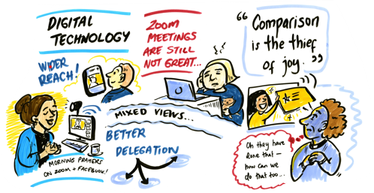
Clergy were asked if they felt new digital technologies and strategies emanating from the pandemic had helped or added to ministry demands. Mostly, these were seen to either have helped, to have been delegated to others or simply to have dropped away post-pandemic.
- Zoom was welcomed for enabling meeting flexibility and freeing up time for other activities. Livestreaming was helpful for enabling access and reach. While in the initial stages of the pandemic demands were very high, digital skills had now been acquired by clergy and congregations are largely accepting of the technologies.
- However, digital technologies had also changed some ministry practices in an unhelpful way. Changing the nature of preaching (now also to an invisible congregation through livestreaming) created its own unique demands: “I’m so glad we stopped streaming as it meant too many limitations on what we could do”. Zoom meetings raised the expectation of availability and could lead to scheduling problems. An increase in screen work raises problems for concentration and fatigue.
- Additionally, easier access to others’ digital offerings could lead to unfavourable comparisons and a felt need to do more. This could extend to feeling pressure to invest in more sophisticated (expensive) technologies.

SUPPORT STRATEGIES
The afternoon session focused on strategies for addressing the requirements and pressures of modern ministry. Each presentation outlined a different strategy for managing demands. In the first case, a therapeutic-type intervention (coaching) and, in the second case, a more structural intervention (organizational re-design of activities).

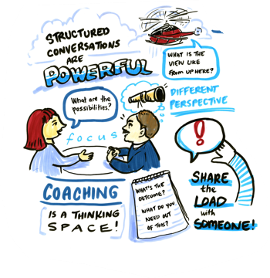
Rev Gill Lovell, Continuing Ministry Development (CMD) Advisor from Oxford Diocese outlined the importance of clergy having Thinking Space where they can “feel heard and get new insights” through discussing issues with another person, who could be another member of the clergy or someone external to the Church.
- Such conversations are intentional and structured, enabling individuals to “think with someone else” in a non-directive and non-judgemental way. They are future focused and optimistic, enabling individuals to “share the load” with someone else
- The structure for such conversations follows the CLEAR convention: beginning with Contracting (what will be discussed), deep Listening, Exploring the issue, Identifying an Action to be taken as a result and Reviewing the conversation for emergent insights.
- Oxford Diocese has a system of Ministry Accompaniers, where volunteers provide this thinking space for any clergy who would benefit from this intervention. Clergy are advised to contact their Parish Development Advisor to pursue this further.
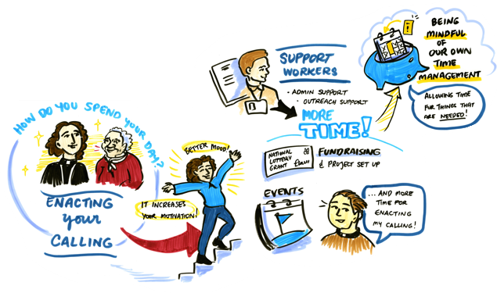

Prof Neil Conway on behalf of the research team from the Supporting Effective Ministry Project outlined a two-stage project within Sheffield Diocese exploring how clergy motivation is affected by activities during their working days and their opportunities to enact their calling.
- In the first phase, and using an innovative daily diary method, the team found that clergy reported admin as their most time-consuming task, taking around 3 hours per day. By contrast they spent only 1 to 1.5 hours per day on activities more closely associated with their calling (e.g. preaching, pastoral ministry etc). These activities were associated with varying levels of motivation with those able to enact their calling reporting higher motivation than those less able to enact their calling.
- On the basis of these results, an intervention introducing shared admin assistants was implemented which enabled clergy to spend more time on their more calling-oriented activities.
- A follow-up survey indicated that clergy with support worker spent more time on and were more satisfied with, for example, mission activities, organising novel events and training volunteers, while also experiencing higher weekly attendance at church and increased income.

Group Discussions of Support Strategies
The five discussion groups were asked to consider three questions around managing demands (see Appendix). Major themes from these discussions are summarised under three headings below.

Reflecting on the suggested interventions
- Participants were generally positive about interventions based on coaching, including pastoral supervision, peer coaching and ministry accompaniers. Having the same person over a period of time enabled reflection on continuing issues (“a trellis not a crisis”) and a sense of “I am in this with you”. Many reported very positive personal experiences of these and related interventions (e.g. Spiritual Director). Some had employed coaches or work consultants privately. Individuals have different requirements in this respect, for example, some might prefer an external coach from outside the Church, while others liked the idea of peer coaching. Experience suggested it was important to find the right “wise guide” and important to have “intentional space and time” built into ministry.
- Participants also generally agreed that they did not find administrative tasks as motivating as activities that allowed them to enact their calling. This could feel like “wasted time” and be quite draining. Having an admin assistant would enable delegation of distracting admin tasks. However, there was also a view that admin can be positive in that it enables a feeling of achievement and it can also be a useful “buffer or escape time”, when clergy are not visible to others. Managing an administrator brings its own demands (including financial).
- Beyond suggestions from the talks, participants also stressed the value of retreats and sabbatical leave, national (non-diocesan) support networks, diocese training events, online sermons and podcasts, the Festival of Preaching and the CMD grant (which can be used to fund retreats).
However, participants also suggested a more complex view of potential support strategies, including questioning some underlying assumptions. We return to this in the final sub-section of this summary.

Current strategies for managing own demands

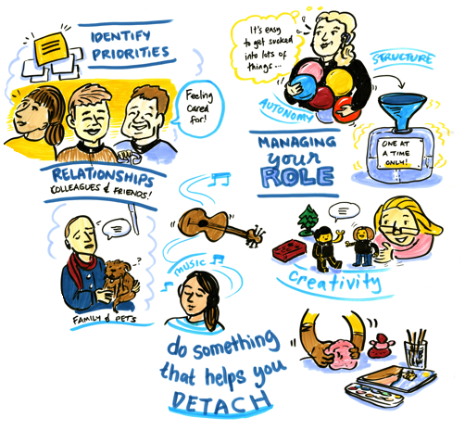

Participants shared a number of personal strategies that they had found helpful in managing their own demands. One participant noted that “being told how to manage demands doesn’t help” suggesting that such strategies are ideally self-developed. However, there is much to learn about options and experience from peers in this respect.
- Clergy received support from a variety of social networks both from within the parish and their own family. Some had reliable paid administrators, but churchwardens and an engaged congregation were also important. Peer groups/friends and spouses act as ‘sounding boards’ and provide ‘safe spaces’ to vent any frustrations.
- Relatedly overt appreciation from congregation, parishioners, colleagues, Bishops and other senior clergy was highly valued. Clergy experienced this in relation to the occasional offices of weddings, funerals and etc but not more generally.
- Setting up efficient internal systems such as shared calendars, establishing work patterns and practising good time management helped in keeping tasks within bounds, and enabled delegation and cover for times when clergy were not available.
- Essential to managing demands was making sure to regularly block time out in advance. These could be ‘quiet’ days as part of the working week or more substantial periods of time away. The important thing was to do this regularly, well in advance and to make sure these were clearly visible to others.
- It was also regarded as important not to compromise on valued hobbies. Music, walking, exercise classes, learning new skills outside ministry were all regarded as important in providing time away from parish issues.
- Underlying these was the importance of self-awareness, recognising triggers and ‘red flags’, understanding one’s own priorities (and communicating them) and advocating for one’s own needs, including setting boundaries and saying no.

Limits to current provision and other requirements
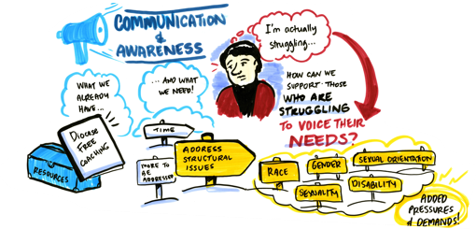

As above, in-depth discussion of possible interventions enabled a more complex picture to emerge. Here, we summarise alternative perspectives on the problem of managing demands and other measures that could help with managing demands.
- At a practical level, clergy reported difficulties with Church information systems and websites that were difficult to navigate. Support and helpful information may be available but it is not well-known or easily found. Additionally, a shared knowledge base of useful information and contacts (e.g. where to find a good architect) would help with duplicated effort.
- Some criticism was expressed in respect to coaching and related interventions. Given existing problems with demands, clergy may experience these well-meaning interventions as more work. Particular projects that introduce new solutions (e.g. admin assistance) may be short-term and, when finished, create more work as clergy have to pick up these new roles and expectations.
- However, additionally, such interventions focus too much on clergy - positioning this group as ‘the problem’ - and on individuals. Interventions aimed at individual clergy ignore more structural issues. Some participants felt that the increase in demands was emanating from structural and cultural changes in the Church and could not be resolved without also considering interventions at this level, including considering changes to other roles within the Church.
- There were mixed evaluations of the efficacy of Ministry Development Review (MDR). Some reported finding MDR beneficial however others suggested it was too performance-focused and prescriptive (“a tick-box exercise”), not taking into account individual contexts and concerns. Additionally, MDR can be a source of anxiety because of the potential for disciplinary proceedings and this undermined trust in the process.
- Concerns were raised that wellbeing interventions are Church-driven and therefore removed from the everyday experience of ministry. It was suggested that more “grassroots” consultation and interventions driven by clergy would be valuable. “Sharing ideas and responsibilities … creates community” and empowering may be more effective than top-down driven interventions. Consequently, “this shows the importance of days like today [this workshop]”.
- Throughout the day, there had been much discussion of vocation, meaningful ministry and calling, as a fundamental and important aspect of ministry. However, several caveats were raised. Positioning administration as antithetic to vocation may be inappropriate. In the first place, it may be hard to judge where to draw the line between admin and ministry and admin can be regarded as part of vocation. More pragmatically perhaps clergy should “just accept that there are bits you like and bits you don’t like”.
- More fundamentally, calling was described by one participant as “overcooked” and led to feelings of “never being enough”. Relatedly, there is a sense of “struggling with autonomy”. When there is discretion over time use, overwhelming demands and no line manager, then it is easy for clergy, driven by a sense of vocation, to downgrade self-care. Participants emphasised that it was important to ask for help and not try to be a “superstar”.
- Role modelling by senior clergy would help in “giving permission” for self-care. This would include being encouraged to take a sabbatical rather than this being entirely self-initiated.
- Importantly, there was wide recognition that those who most needed help were those least able or likely to ask for it. Systems needed to be in place to identify those needing help with advice on how to use the support available more effectively.

Post-Event Reflections
- At the workshop, there was no focused discussion of the experiences of clergy from marginalised groups, a serious omission. Reviewing this, we could have asked a specific question to prompt this discussion. This could encourage participants to share experiences and draw attention to the need for sensitivity, openness and specific support. In the small group discussions, clergy recognised the importance of inclusivity at such events and more widely within the Church such that particular individual characteristics and/or marginalised identities are not exceptionalised or problematised.
- From the feedback, we noted that some participants expected a greater range of interventions. Participants also highlighted the issue of focusing on individual rather than structural interventions. We viewed the introduction of administrative assistance as a structural issue as it involves introducing new roles, however, this did not fit participants’ interpretations. Looking back now, we could have consulted on the content of the workshop with a greater range of clergy which might have revealed these limitations. However, we also believe that effective interventions will come from collective discussion rather than only external suggestion.


Future Actions for Further Discussion and Development
This is a summary of broad ideas on ways in which the Church can work towards achieving a meaningful yet sustainable pattern of ministry. These suggestions represent the experiences and perspectives of the people who attended the workshop, and we recognise that some of these interventions may already be in hand in some Dioceses. An important next step would be to use this report as a prompt for further discussion and developing the issues into more focused and detailed strategies for practice in consultation with clergy.

Training
- Reviewing current vocational training with a view to broadening students’ exposure to the issues of everyday ordained ministry including practices that enable management of demand.

Everyday Ministry Practice
- Identifying ways in which clergy can build “intentional space and time” into their ministry and include those activities that feed vocation.
- Deaneries to encourage clergy in self-care, advocating for their own needs and recognising where expectations they have of their own role and personal resources may be unrealistic.
- More transparency and negotiation over expected activities/goals for clergy and how these can be achieved from the Diocese.
- More overt appreciation from Diocese and national Church of individual clergy activities, beyond the more easily recognised and celebrated activities of larger churches.

Supporting Clergy with Overwhelming Demands
- Explicit recognition and acknowledgement of specific demands and challenges related to membership of marginalised groups within the Church, working towards designing measures to alleviate.
- Clergy to work towards consciously recognising triggers coming from over-demand and to seek support with re-prioritisation and additional resource in a timely manner.
- Establishment of systems to identify clergy who need support and enable proactive offers of help.
- Sources of support to be clearly advertised, recommended by senior clergy and clergy encouraged to ask for support when needed.
- Advice offered to clergy on how to use the support available effectively and clergy supported in the process of finding the right “wise guide”.
- Explicit role modelling of sustainable ministry by senior clergy to legitimise clergy self-care.
- Review of current mechanisms of support through senior clergy: are all senior clergy aware of importance of timely intervention and have the skills to support clergy when needed?
- More visible publicising of available interventions (e.g. beyond website listings).

Bottom-Up Group Level Interventions
- Diocese and other groups to consult with clergy over potential interventions and encourage grassroots suggestions for potential interventions.
- Explicitly schedule sharing of experiences and personal strategies for managing demands with others in local Benefice or Deanery so clergy know they are not on their own and that struggle with demands is not an indication of individual failing.
- Set up series of grassroots discussion of experiences with demands and suggestions for change within Deaneries with two forms of output (1) contextually-appropriate changes to be implemented locally (2) ideas for institutional change to be fed back to Diocese and national Church for action.
- Create support groups within Deaneries to share advice, personnel, and other resources.

Changes at National Church Level

- Explicitly recognise that the responsibility for the ministry of the Church has to be shared more widely beyond the parish and Benefice.
- Move towards a more ‘relationship’- as opposed to ‘transactional’-based mode of interactions and operations between clergy, the Diocese and the national Church.
- Establish the long-term viability of interventions prior to roll-out to avoid inadvertently creating more work for clergy.
- Identify a portfolio of intervention options to fit different situations.
- Improve national Church and Diocese information systems and develop a shared knowledge base of helpful sources of expertise at Diocese level.

Planned Post-Event Activities
At the end of the event, participants were asked to describe one change they intended to make as a result of the workshop. Here we present some of those intentions.
Ensure that I prioritise one thing a day that links directly to my sense of vocation/calling
Pick up the phone to a couple of clergy I know are struggling
Offer to serve as a ministry accompanier
To use my paid colleagues more effectively and trust them with taking on more
Walk more in order to slow down and reflect
Look at the Living Ministry Web site
Talk to someone about managing my emails
Pay more attention to the well-being of the clergy in our neighbouring parishes
Feedback
The small group discussions after each talk were really helpful

This was good - as the day progressed the conversation became deeper

Disappointed that the representation wasn't better, particularly from York province of the CofE. It's good to be able to share experience and recognise the resonances we have named. People need to know that they're not on their own! I wonder if this research could be shared in York.

I think I’d hoped for more strategies, resources, suggestions etc to help us manage the demands of modern ministry - but maybe that was unrealistic

Thank you so much for yesterday. I found it very useful and met some very interesting and compassionate people.

Venue worked well
Food was great
Well facilitated
Good relevant useful content

An excellent day. I really enjoyed the talks and the group discussion. We got to know each other and share our experiences.

It was good to have the results of recent research presented to us. It tended to confirm the ideas that I had gained from others that I had talked with. It has also made me aware that the responsibility for the ministry of the church has to be shared more widely within the church community.
The day was beautifully organised … Many thanks for looking after us so well - lunch was a real treat and ‘fed in’ to the general ethos of wellbeing and care.

Appendix: Template for Workshop

Rationale and Aims
Our purpose here is to outline a process that can be adopted by clergy for discussing demands and wellbeing specifically at a local level such as a Deanery. The aims of such an event include:
- Bringing local clergy together away from their everyday tasks to focus on their own needs
- Encouraging joint discussion of demands and challenges in an open manner
- Working on ways to implement local context-based solutions while feeding back more general ideas to Diocese and beyond.
In our opinion it is important that such events be face-to-face rather than online. Although online provides greater access, it may not give sufficient space away from everyday concerns of ministry (time out) nor provide the emphasis on self-care required. It is important also that clergy spend quality time together to connect and build relationships. This should be viewed as an important investment of time rather than an event to be squeezed into a busy daily schedule. Planning this as a local event helps make it more accessible.
We are advocating that such an event be run with local clergy. This is to encourage the attention to local context and possibilities for immediate local action, including ownership of any changes. Whether more senior clergy should be in attendance is a complex issue. The presence of senior clergy may give more weight to the discussion and enables confronting wider issues in the Church but could also discourage full and frank discussion. If senior clergy do not attend, broader suggestions for change arising from the workshops should be fed back to the Diocese.
General Overall Design
- Introduction to the purposes of the day
- Talks, podcasts or pre-reading presented or summarised
- Capturing of reactions in written form (post-its and note-taking)
- Sharing of own related experiences and discussion in response to targeted questions
- Identifying of immediate and more long-term actions as an outcome of discussion
- Shared refreshments
- Production of summary for circulation

Explaining this Design
- A talk from a local expert such as CMD or Wellbeing Advisor or a podcast from a researcher working in the area is important so that participants are being exposed to new information but most importantly because this acts as a trigger to the discussions. We have produced videos of our presentations at this event which can be downloaded at Videos for ‘Beyond Balance’ Event. This could be preparation for the workshop or viewed at the time. Event organisers are welcome to use all or a subset of these or to extract any elements of these they find particularly useful. Please note that the recordings by Gill Lovell and Neil Conway were recorded at the event but, due to some technical issues, the recordings by Liz Graveling and Gillian Symon were recorded post-event.
- It helps to have at least two discussion sets. In our case a first discussion around Experienced Demands and then on Support Strategies. As discussion progresses, participants become more relaxed and the discussion deepens. More straightforward descriptive questions can then lead on to considering more challenging issues. However, if time is limited, one discussion should utilise a set of questions that enable further probing.
- Allowing time for quiet individual reflection on the questions posed before moving to small group discussions allows individuals to gather their thoughts. Recording these initial thoughts on post-its (1) enables those who feel less able to share verbally to voice their opinions (2) prompts discussion of the questions (3) captures thoughts for later sharing and feedback.
- A group facilitator for each group enables the conversation, keeps the group focused on the questions, encourages everyone to speak if they wish and takes notes for later sharing and feedback.
- Providing shared refreshment is important to allow relationship-building, more informal mingling and as demonstrating the care for clergy that prompts the event.
- Producing a summary afterwards is partly a reminder of what was discussed but also acts as a commitment to the issues that have been raised. Participants feel heard and actions captured can be pursued.
- Overall, it is important to manage the event sensitively. Participants should be ensured of confidentiality and discussion should be non-judgemental. Measure should be in place to direct any clergy who require immediate support to the relevant agencies.

Group Discussion Process
(F= group Facilitator; P=participants)
- Form into small groups of 4-6 Ps plus one F.
- Start with brief introductions (if relevant).
- Two or three questions presented to discuss for 15 mins each:
  - Ps note down immediate responses on post-its.
  - F asks for post-it responses to each question in turn to open up discussion
- F takes notes from the discussion as it proceeds.
- At the end, two group Fs asked to summarise the responses to one question each for the room with additional points requested from other groups. This opens up the discussion to the whole group for further thoughts.
- At the end of the discussion sessions, Ps stick post-its to flip charts (or a wall) according to question so they can browse all responses across groups. NB. post-its retained for later reporting.

Possible Group Discussion Questions
In this workshop we asked the following questions:
Experienced Demands
- Thinking about the talks you have listened to this morning, were there any points with which you particularly identified or that you didn’t recognise?
- What do you feel are the ‘invisible’ or unacknowledged demands made of you?
- Have the digital strategies developed during the pandemic created further demands or helped in coping with demands?
Support Strategies
- Thinking about the talks you have listened to this afternoon, were there any suggestions with which you particularly identified or that you didn’t find helpful?
- What helps you in managing the demands placed on you? What doesn’t help?
- What external support is available to you and is it helpful? If not, what would be helpful?
These could be fewer and/or changed depending on emphasis. For example, we asked Q3 because of our own interest in the use of digital technologies in ministry.

More Information
For more general information on running group discussions and focus groups, please see:
- Oates, C. and Alevizou, P. (2018). Conducting focus groups. London: Sage Publications
- https://researchmethod.net/focus-groups/

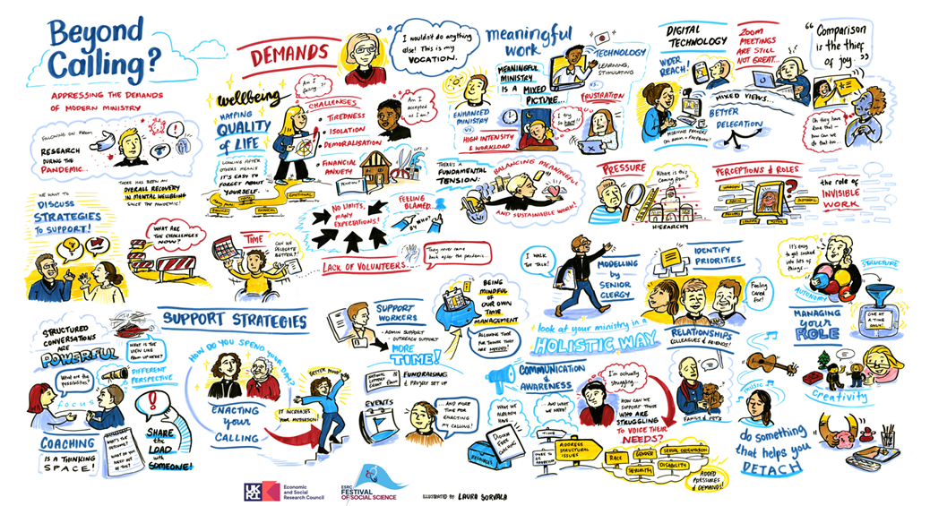

All the presentations given at the event can be found at Videos for ‘Beyond Balance’ Event.

